 VINOD SIR’S GROUP TUTION

MARKS: 16 IX-MATHS-I TIME: 1 Hr. 30 Mins.

Q. 1: Do as directed: (Each question contain 2 marks) [8]

1. Write the following sets in roster form.
1. Set of even natural numbers
2. Seven basic sounds of a sargam (sur)

2. Write the following sets using listing method.
1. Set of human sensory organs.
2. Set of prime numbers from 1 to 20.

3. Write the following sets using rule method.
1. C = {S, M, I, L, E}
2. B = { 6, 12, 18, 24, 30, 36, 42, 48}

4. 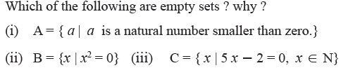

Q. 2: Do as directed:

1. 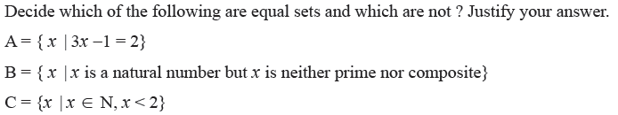 [3]

Q. 2. Write with reasons, which of the following sets are finite or infinite. [2]

1. Set of apparatus in laboratory
(ii) B = {y | y < -1, y is an integer}
(vi) Set of whole numbers
2. 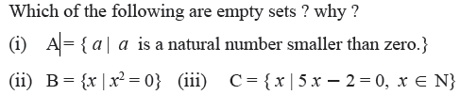 [3]

